**SMART CAR BARRIER**

**Abstract:**

In the early times the concept of smart cities has gained great popularity. The smart car barrier system consists of an on-site deployment of an IOT module that is used to monitor the vehicles. Here we will make a smart car barrier system which is used in toll tax systems on highways, smart car parking systems, automatic gates etc. by using Arduino, a servo motor and ultrasonic sensor. The objective of this project is to create an automatic gate control system which can be implemented easily in parking lots. Generally, there are manual gate control system which are maintained by person. As vehicles are increasing day by day it has become more difficult to control the gate manually. This can help us to reduce manual efforts by introducing automatic gate control system.

**Materials:**

Arduino, Ultrasonic sensor, Servo motor, Jumper wires, Battery connector, battery.

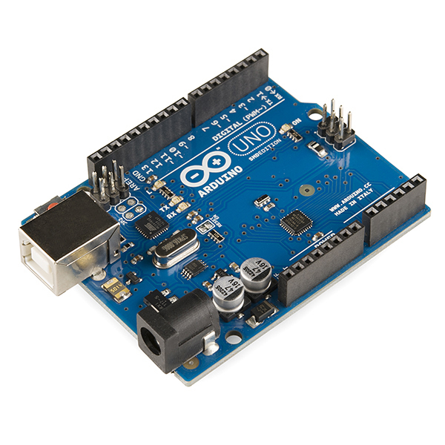 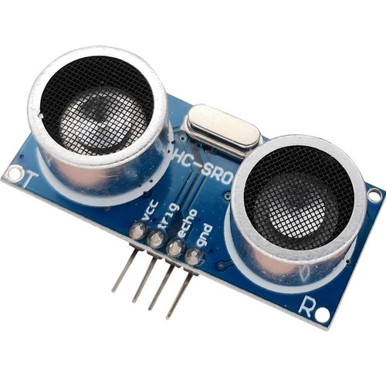

Arduino Ultrasonic sensor

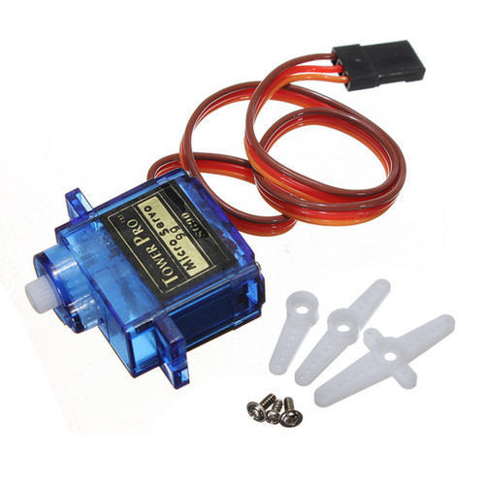 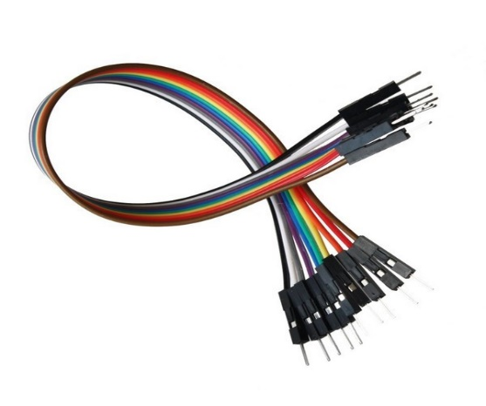

Servo motor Jumper wires

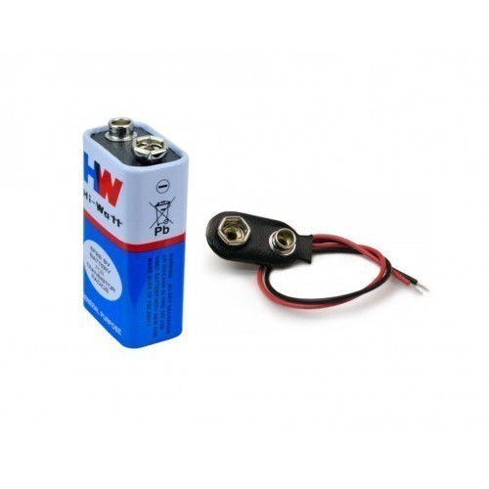

Battery and Battery connector

**Circuit Diagram:**

